Name Khan Adnan Tanweer Alam  
UID No. 2022301008   
Class & Division COMPS A (BATCH C)  
Experiment No. 2

Aim: Experiment on finding the running time of an algorithm(merge sort and quick sort)

Theory:

Merge sort  
Merge sort is a sorting algorithm that works by dividing an array into smaller subarrays, sorting each  
subarray, and then merging the sorted subarrays back together to form the final sorted array.

In simple terms, we can say that the process of merge sort is to divide the array into two halves, sort each half, and then merge the sorted halves back together. This process is repeated until the entire array is sorted.

One thing that you might wonder is what is the specialty of this algorithm. We already have a number of sorting algorithms then why do we need this algorithm? One of the main advantages of merge sort is that it  
has a time complexity of O(n log n), which means it can sort large arrays relatively quickly. It is also a stable sort, which means that the order of elements with equal values is preserved during the sort.

Quick sort

Like Merge Sort, Quick sort is a Divide and Conquer algorithm. It picks an element as a pivot and partitions the given array around the picked pivot. There are many different versions of quickSort that pick pivot in  
different ways.

• Always pick the first element as a pivot.  
• Always pick the last element as a pivot (implemented below)  
• Pick a random element as a pivot.  
• Pick median as the pivot.

The key process in quickSort is a partition(). The target of partitions is, given an array and an element x of an array as the pivot, put x at its correct position in a sorted array and put all smaller elements (smaller than x) before x, and put all greater elements (greater than x) after x. All this should be done in linear time.

Algorithm:

|  |
| --- |
| Merge sort: |
| 1. If the array “b” has only one element, return the array as it is already sorted.  2. Calculate the middle index of the array “b” using "mid = (beg + end) / 2".  3. Call the "mergesort" function recursively for the first half of the array "a[beg, mid]".  4. Call the "mergesort" function recursively for the second half of the array "a[mid+1, end]"  5. Call the "merge" function to merge the two sorted arrays obtained from the previous steps back intothe original array “b”.  6. The "merge" function takes in two arrays, the first half and the second half, and sorts the elements inboth arrays and stores them back into the original array “b”.  7. Repeat the above steps until all elements of the array “b” are sorted in ascending order. |

|  |
| --- |
| Quick sort: |
| 1. If the array “b” has zero or one element, return the array as it is already sorted. 2. Choose the first element of the array “b” as the pivot.  3. Initialize two variables “low” and “high” to keep track of the elements to be swapped. Set “low” to the first position and “high” to the last position in the array “b.”  4. While “low” is less than “high,” repeat the following steps: a. Increment “low” while the element at “low” is less than or equal to the pivot. b. Decrement “high” while the element at “high” is greater than the pivot. c. If “low” is less than “high”, swap the elements at “low” and “high”.  5. Swap the pivot with the element at “high” to place the pivot in its correct position in the sorted array.  6. Call the quick sort algorithm recursively for the two sub-arrays "b[beg, high-1]" and "b[high+1, end]".  7. Repeat the above steps until all elements of the array “b” are sorted in ascending order |

|  |
| --- |
| CODE :- |
| #include<stdio.h>  #include<stdlib.h>  #include<math.h>  #include<time.h>  void dataInput() {  //generate 100000 random numbers  srand(time(NULL));  for (int i=0;i<100000; i++)  {  int temp = rand();  FILE *fptr;  fptr = fopen("DataSet.txt", "a");  fprintf(fptr, "%d\n", temp);  fclose(fptr);  }  }  //swap function  void swap(long *xp, long *yp) {  long temp = *xp;  *xp = *yp;  *yp = temp;  }  //merge sort algorithm  void merge(long arr[],long temp[],int mid,int left,int right) {  int i,left_end,size,temp_pos;  left_end = mid-1;  temp_pos = left;  size = right-left+1;  while((left<=left_end)&&(mid<=right)) {  if(arr[left]<=arr[mid]) {  temp[temp_pos] = arr[left];  temp_pos = temp_pos+1;  left = left+1;  }  else {  temp[temp_pos] = arr[mid];  temp_pos = temp_pos+1;  mid = mid+1;  }  }  while(left<=left_end) {  temp[temp_pos] = arr[left];  left = left+1;  temp_pos = temp_pos+1;  }  while(mid<=right) {  temp[temp_pos] = arr[mid];  mid = mid+1;  temp_pos = temp_pos+1;  }  for(i=0;i<=size;i++) {  arr[right] = temp[right];  right = right-1;  }  }  void mergeSort(long arr[],long temp[],int left,int right) {  int mid;  if(right>left) {  mid = (right+left)/2;  mergeSort(arr,temp,left,mid);  mergeSort(arr,temp,mid+1,right);  merge(arr,temp,mid+1,left,right);  }  }  //quick sort algorithm  int partition(long arr[], int low, int high) {  int left, right, pivot_item = arr[low];  left = low;  right = high;  while(left<right) {  while(arr[left]<=pivot_item) {  left++;  }  while(arr[right]>pivot_item) {  right--;  }  if(left<right) {  swap(&arr[left], &arr[right]);  }  }  arr[low] = arr[right];  arr[right] = pivot_item;  return right;  }  void quickSort(long arr[], int low, int high) {  int pivot;  if (low<high) {  pivot = partition(arr, low, high);  quickSort(arr, low, pivot-1);  quickSort(arr, pivot+1, high);  }  }  int main(int argc, char const *argv[])  {  //gen data  dataInput();  //read data from file  FILE *fptr;  fptr = fopen("DataSet.txt", "r");  long arr[100000], arr1[100000], arr2[100000];  for (int i = 0; i < 100000; i++)  {  fscanf(fptr, "%8ld", &arr[i]);  }  fclose(fptr);  int s = 100;  printf("Size\tMerge Sort\tQuick Sort\n");  for(int i=0;i<1000;i++)  {  for(int j=0;j<s;j++)  {  arr1[j] = arr[j];  arr2[j] = arr[j];  }  double diff1, diff2;  struct timespec start, end;  //merge sort  clock_gettime(CLOCK_MONOTONIC, &start);  long temp[s];  mergeSort(arr1, temp, 0, s-1);  clock_gettime(CLOCK_MONOTONIC, &end);  diff1 = (end.tv_sec - start.tv_sec) + (end.tv_nsec - start.tv_nsec);  //quick sort  clock_gettime(CLOCK_MONOTONIC, &start);  quickSort(arr2, 0, s-1);  clock_gettime(CLOCK_MONOTONIC, &end);  diff2 = (end.tv_sec - start.tv_sec) + (end.tv_nsec - start.tv_nsec);  printf("%d\t%f\t%f\n", s, diff1, diff2);  s += 100;  }  return 0;  } |

Output:

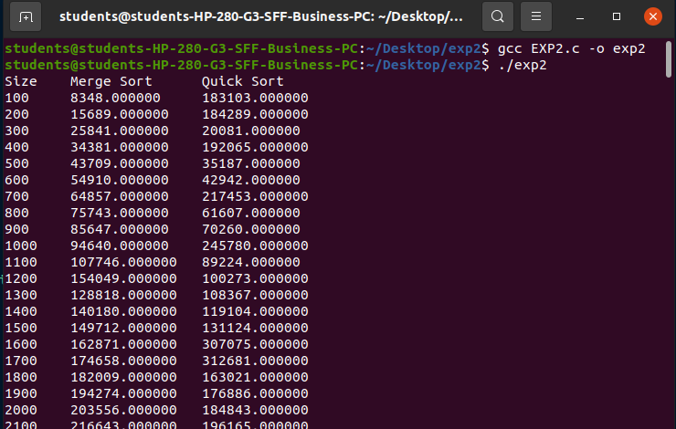

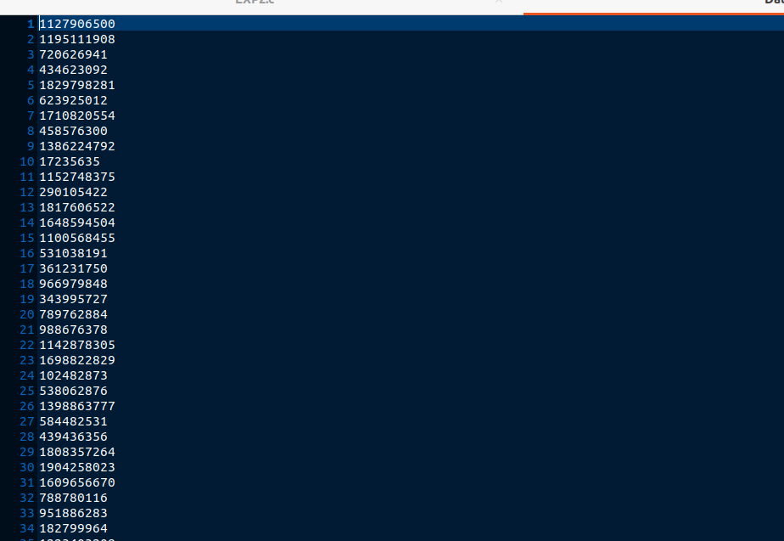

Graph:

**Observation:** For the initial lower input numbers, both merge and quick sort provide results in almost similar runtimes. Quick sort is a tad bit faster than merge sort for higher number of inputs.

**Conclusion:** Quick sort takes less runtime and hence is a little more feasible than Merge sort for higher number of inputs.